Conjugate Gate Mythal

Information for friend Bitflipper
Kreen intends to build a conjugate gate that will persist beyond Kreen's need for immediate use due to the resources Kreen must acquire to build the metasentient that manages the connection on this plane. It provides this document so friend Bitflipper can inform those that need to consider the effects. Despite Kreen not being too familiar with common it will do its best to work slowly in this document so Kreen can be best understood. A basic site plan is provided on the second page.
This type of mythal is called a metasentient though its purpose is for a conjugate gate. This is a heavily modified form of high elven mythal from its plane though historical recording of mythal structure is outdated. Mythals themselves are best described as self-perpetuating multipurpose spells over a large area. This specific mythal will range a 3km radius as to ensure a power aggregation that can spread safely over a sufficient distance. Construction cost accelerates rapidly at the point where the drain per unit life crosses the amount of power input to increase range as with the diagram to the right. These mythals more resemble human spell work of a similarly high circle but center around a metasentient construct that controls and regulates. They were researched during the late age of Netheril for the specific purpose of conjugate gates. Normal construct minds proved inadequate for handling the multi-prime material aspect and having an equivalent amount of mages concentrating for extended periods proved infeasible. The power consumption of the metasentient alone is quite large and it is likely the gate will only be able to be sustained for a half hour at first. It provides a diagram to the right for power consumption at different stages of gate travel. The stages are covered in the summary at the end as well.(3) Sourcers are included in this design to act as a buffer to the primary mana shunt and the Mythal will include a capacity to further the plant density and fertility of the forest in order to artificially enhance mana production in the short term though with the possibility to continue over the potential of an extremely long term.

Metasentient mythals are not intelligent constructs with defined intellects like golems; they are more like Kreen. The intelligence of the metasentient is formed of the base intellect plus those sentients connected willfully into the core as token bearers. The metasentient may use their minds for its own thoughts though does not mean that these thoughts are somehow borrowed or stolen but that they are used in place. (4) In this way no removal or movement transaction occurs so there can be no damage to the host mind. Storage of memories in token bearers is possible but this is not a functional alteration of thoughts in the host mind as they remain unlinked unless effort is taken by the token-bearer to link them. This protection in use of small discrete pieces of a mind employed allow so that even though the token bearers compose the intellect they do not control the whole directly. Even so the intellect is made of them so it would not hurt them unless they would hurt themselves. All instances in arcane research Kreen is aware of demonstrate this level of care for token bearers that matched care for the self. This care by extension means the metasentient cares deeply for all those all the token bearers care for deeply. Also this follows that it hates the ones that the token bearers hate. In order to prevent the latter behavior precepts are added in construction to direct the whole toward acceptable behavior whether the token bearers are consciously inclined to it or not. The precepts affect which parts of mind the base intellect chooses to employ to process thoughts and how it implements this process.

Precepts
Kreen will encode the following precepts into the core of the metasentient.
- Incite no lasting harm to the living by choice as long as they bring no lasting harm to others.
- Undo lasting harm as best able unless doing so violates precept the first.
- Secret no knowledge from token bearers unless to do so violates precept the first.
- Foster the forest and prevent those from exploiting it without prior agreement of all token bearers.
- Let no unknown wander the forest unobserved.

Token Bearers
Token bearers are a large part of the function of the metasentient though it can in part persist without them so Kreen will first describe token structure in detail. As the conjugate gate is tightly connected to Kreen it will retain final authority over admitting or refusing token bearers which cannot be revoked by the metasentient. The tokens Kreen mentions can be any object that an intelligent being regards as important to them in more than a superficial fashion. This important item could not be a flag with no personal meaning other than affiliation in an army but a weapon belonging to a fallen brother could. It serves as a central entry point into the mind of the token bearer and helps the metasentient identify the different minds from each other. This token serves as an entry point only into conscious minds so the sleeping are both invisible and useless to the metasentient. Token bearers can be reached only inside of the mythal's effective range so though a 'copy' of the token will remain in the metasentient the token bearer adds no distinctiveness outside the mythal's range. Outside the range of the mythal arcane marks on the physical token will be visible to the naked eye that serve as a reminder to the metasentient as to how much time has passed since the token left its awareness. It provides two examples of this. The first is one that came from a well established metasentient under netheril care. The second is Kreen's best guess at a newling metasentient interpreting friend Bitflipper's own patterns. Kreen sees only the surface energies of friend Bitflipper but as a mark of a birth year it should prove similar.(5) This is necessary to resume contact with the token bearer upon reentry. The token itself must otherwise remain with the bearer at all times in order for the metasentient to maintain its connection. A facility to ensure the tokens can be replaced if damaged will be described later. If an arcane mark is removed outside the mythal or the token partly damaged it may take time for the metasentient to integrate new memories from the gap in time from exit to reentry. The marks themselves change rapidly over time and are difficult to fake as Token bearers will know their own through the metasentient. False tokens will provide no awareness to the metasentient as it will be unable to find or identify a proper entry point in the bearer from just a token.

Role of Token Bearers
The role of token bearer is integrated into many of the metasentient's functions and its capabilities will improve based on how many individual token bearers there are as its available mental capacity will expand. The metasentient can augment individuals with the collated skill of the whole to a certain extent though it cannot give new skills to the untrained. If a token bearer does not possess enough knowledge of something to understand what to look for the metasentient will not be able to find anything either. Some physical capabilities ingrained in physical memory will be inherited by the metasentient such as unarmed fighting. This chance is posed to some of the token bearers that they may be able to access these instincts if the metasentient attempts to augment an activity. If not otherwise occupied the metasentient will assist in the functionality of the token bearers in whatever capacity they are currently operating. Though it is attentive to token bearers the metasentient does have other duties as well a collective will of its own guided by the precepts though it will inherit a great deal of skills from token bearers. This may make those thoughts it borrows busy and more difficult to access by those it takes them from in first but it should not task those that are mere donors. Spells are much like motor memory to the metasentient and it can employ them directly from inside a caster's mind to its directed ends but Kreen expects it to do this on a very rare basis and the token bearer in question must willingly participate. Such a use of a token-bearer's power would be cast as if the seers were a familiar but even though the token-bearer assembles the effect the metasentient will determine how and where it is deployed. This also works in the reverse as token bearers can handle seers directly to allow more efficient uses in most cases. In other cases the token bearers are required in the locality for the metasentient to have enough intellect to cast the effect.
As an example Kreen posits the following situation. The mythal has eight token bearers each of varied specific skill sets: healer, guard, ranger, carpenter, animal handler, mage, soldier, and archaeologist. It will refer to them as numbers 1 through 8 respectively in the diagram on the following page. (6) Each contributes the body of their own knowledge to the metasentient. Should the metasentient become aware of a way to assist a token bearer it must still choose a first from which to locus the skills with and provide assistance to a particular being. This makes it difficult for those of high skill to receive a measurable increase in skill if none of the other token bearers can be used as a locus of at least equal skill. The metasentient cannot contribute very productively to that which it cannot understand equally. As to the diagram - if a guard, whom has only a passing knowledge in healing others like him is actively engaged in doing such, the metasentient can use the healer as a locus and contribute the passing attentiveness of the three other token bearers that have such skills. If the healer takes over of the activity the metasentient would desist and though no longer used as a locus the healer's body of knowledge will increase only slightly his focus from those that remain as no other is of similar skill complexity to collate knowledge. The archaeologist, digging in a tunnel may gain the instinctive awareness of bending nails creaking in a failing tunnel strut due to the the guard's proficient hobby in blacksmithing and the reflexive impulse to vacate the area from the soldier's combat training. The mage may find a greater depth of understanding in the guard's craft but lack the personal knowledge to receive it well enough to employ the skill. Such engaging of intuition for their surroundings among the token bearers is engaged at an instinctive level and though likely common will not leave the recipient with the corpus of knowledge only the end assessment as rendered and copied from the donor minds imaged through the metasentient.

Side Effects
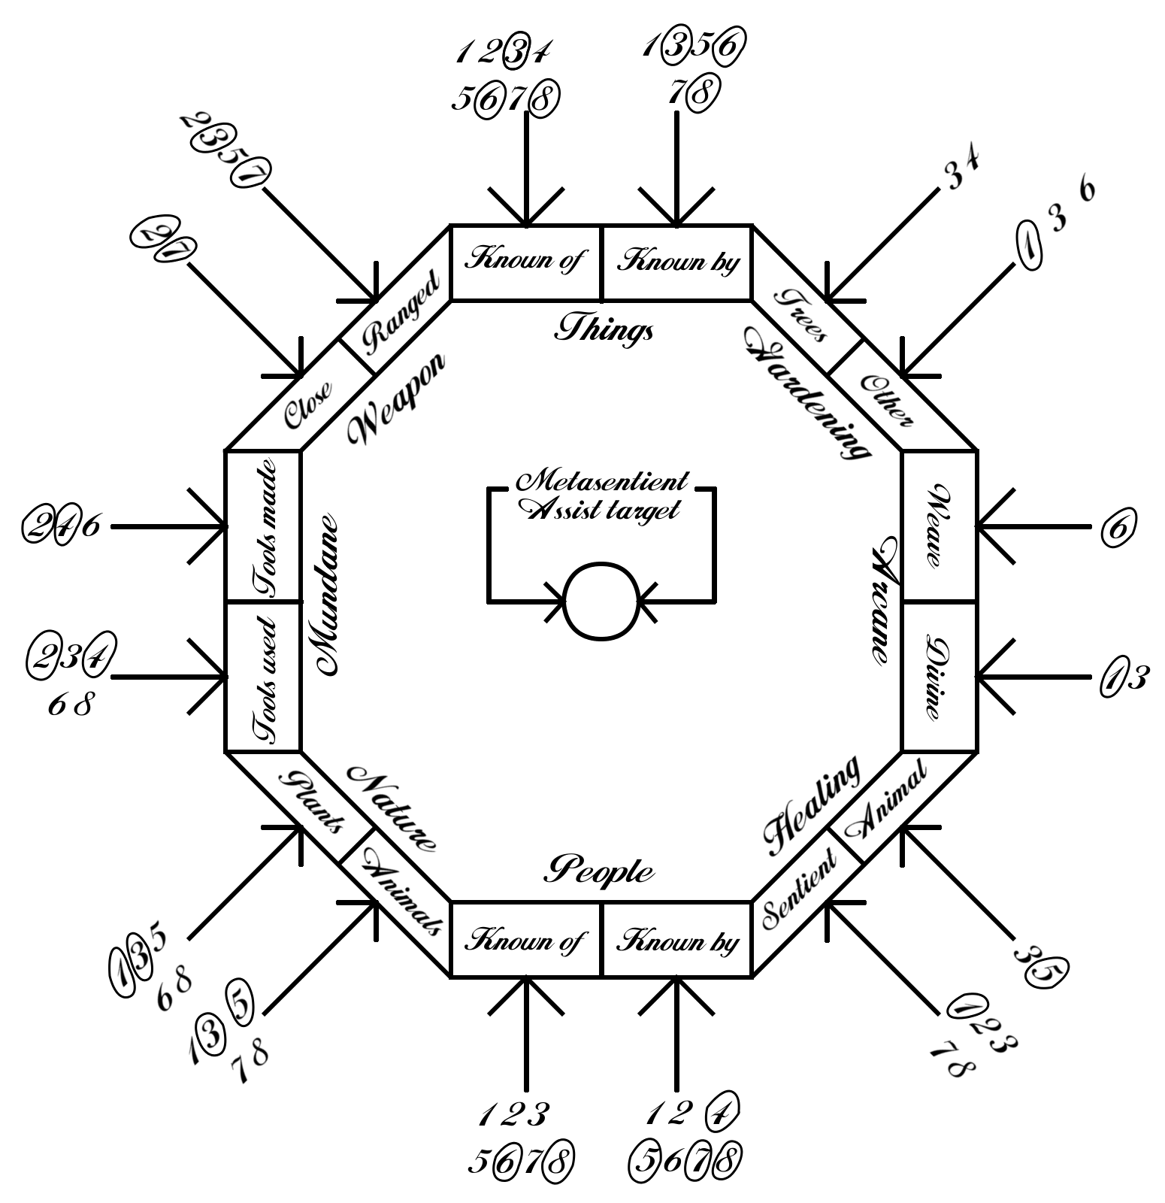Illustration: Skill Diagram for example on previous page
The other difference of this modified mythal is that its powers inherently balance themselves. Kreen can discern the general nature of these balances as they are relatively predictable but they cannot be circumvented without damaging the power they mirror. The side effects of prevalent powers are dependent on the amount of prevalent effects and spells available throughout the mythal as well as their magnitude so Kreen has kept such spells to a minimum. The nature of the side effects is also determined by the nature of the powers so Kreen is limited in the effects it can produce as overtly invasive spells used will induce invasive side effects. (7) Kreen will describe Seers later that it will use to side step this limitation since they will be discrete mythallar constructs. This will allow Kreen to ensure the Mythal can affect self-repair and the fostering of the mythal power base over an indefinite term. Primarily this is to avoid strain on environment mana reserves while the gate is active. In sum, if the seer's duties were included as spells available anywhere in the mythal they would wreak havoc in the severity of side effects this would cause.

Inherent Right of Shunted Mythals
Right of denial is also part of the meta sentient as Kreen will attach it directly to the ley node at the intended location. This process is safely done at the point of construction at which this process will be accomplished but this direct link gives the metasentient some local authoritative force. If a magic user is deemed a threat it would be within the metasentient's power to deny any mana to the threat entirely via redirection of fine ley lines. It is unsure what this would do to fey or dragons of friend Bitflipper's plane but Kreen would assume nothing healthy so it will encode such knowledge directly into the metasentient's core. The precepts to not harm the living will prevent any harmful use against the magic-dependent races. This denial will in effect appear as a moving dead magic area as the metasentient prevents distribution of mana into that person's locality while simultaneously evacuating it away from this spot as in the diagram to the right. (8) Kreen expects the metasentient to only manage one such denial at first, perhaps more if token bearers are equal to the total power of another individual to deny. Token bearers can never be so denied however and care must be taken before admitting them to the core. Similarly, druidic magic cannot be denied either as it functions differently than arcane magic in drawing directly from the living surrounding the druid and to suppress the forest would be counterproductive for the metasentient for even a small length of time.
Also of note: a metasentient mythal is designed such that it allows for the use of nature and divine magic though Kreen cannot personally contemplate the patterns for healing magic. Nevertheless Kreen will be using some druidic magic structures in Seers to enhance the forest surrounding the mythal.

Seers
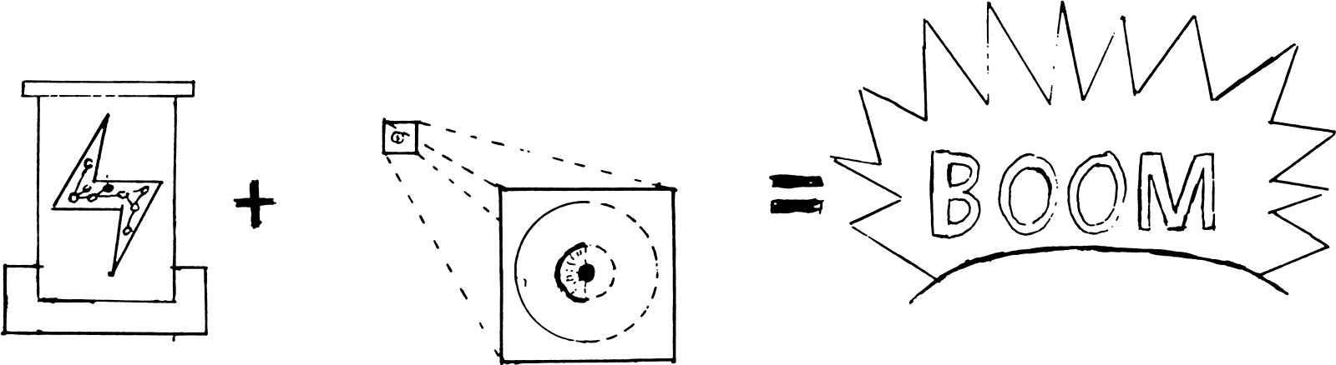
Seers will preform most of the duties of the metasentient so Kreen will discuss first the design options it has completed for them so far. In a physical sense they will appear as fairly small glass eyes about the size of an those in an 8 – 10 year old human. This size is chosen as it is much easier for Kreen to build the mythallar if it finds a strong willing receptacle to power the seers during construction. It may take time to locate a naturally blind child of suitable age with willing guardians but Kreen will make a pair of arcanely inexpensive seers bound to the child in payment for their time and resolve their blindness. This payment Kreen hopes should attract a donor. The Seers may receive damage if connected directly to the metasentient during construction which would prove both lengthy and expensive to prevent so a willing receptacle is the preferred construction method. As it shows to the right an fractured power feed from partial completion can prove unhealthy.(9)
The Seers themselves are constructed with a general glyph template Kreen has memorized that has a few specific features added. The seers will be able to levitate through air as a Seer's method of locomotion. The primary drives are levitation impellers and a rotational spin as in the picture below. The glyph transceiver ensures sealed communications so that unknown persons cannot use the seers for their own benefit through magical means. Should attempts manage to pierce this sealed channel the metasentient will forcibly evict the person from the collective.(10) The levitation impeller is as fast as an adult human's walking speed except for those augmented directly. Seers are resistant to damage in a general sense with the use of reinforcement grids within the construct matter but as Seers will be pure glass a resonant sound may cause damage. Outwardly fragile despite Kreen's enhancement, as Kreen wishes to keep its material costs to a minimum, it will include a desire to flee any hostility and summon more robust token bearers to problems instead. This should also prevent any unintentional injury on the part of the metasentient from proactive instinct responses. Though the metasentient controls the Seers through telepathy the Seers can communicate vision to token bearers should token bearers desire it. This vision may be somewhat undirected as Seers though minimally competent in their own right remain simple mindless constructs with little care for things not relevant to Seers' duties.
Communication with others is rare unless told to do so by core or token bearer. Even when Seers do communicate since Seers do not have an intelligence of their own token bearers will be answered by the metasentient using the questioner's own intellect. Seers cannot leave or interact outside the mythal as it is their power source but should Seers be separated from the metasentient reentry will reestablish control. (11) The diagram to the right indicates the fairly erratic cliff falloff as various communications fail below their minimum baseline strength. If locations are built that resist the mythal they will have a similar falloff at any openings. In matters of control and security Kreen has ensured that the Seers can only receive orders from one mind at a time as to prevent tampering by unauthorized persons. The metasentient would have to relinquish control of a bound seer before control could be taken and powers subverted.
To accomplish their intended purpose the Seers' designs will have certain powers. As with all of the Seers their powers will be presented in order as usable at their will, thrice per twenty four hour period, and once a per twenty four hour period. All powers are designed to be used at a maximum range of 1 meter unless Kreen notes otherwise.

Protectors
Protectors tend to destructive influences within the mythal. They are constructed with an augmented locomotion and will travel nearly running speed of a human though they can move up to four times this speed for medium distances. This locomotion is highly responsive as to allow the seers to be close enough to a target but still dodge most conventional attacks against them at range. Friend Bitflipper has weapons they they are unlikely to dodge but energy weapons of minor quality should still be resisted unless based in sonic effects. Still as to avoid being attacked they are equipped with a capacity to know how to hide conventionally from sight of a given target.
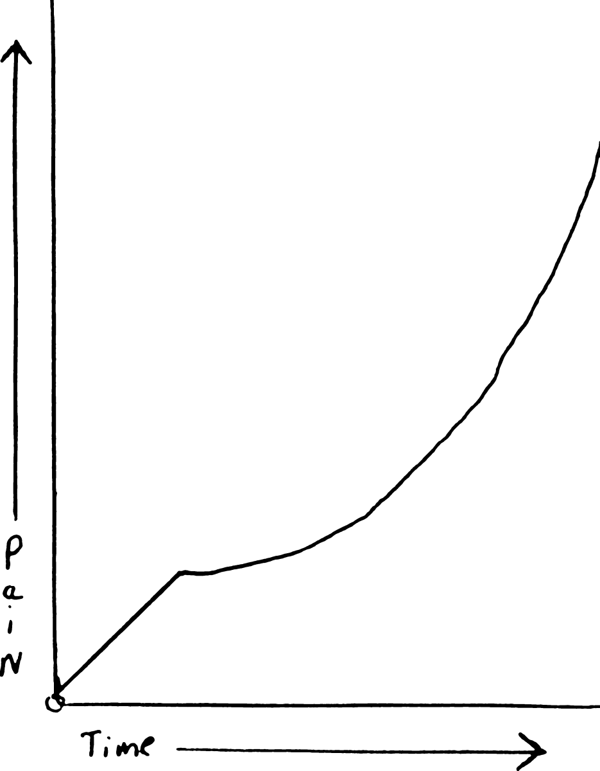
First of Protector powers is to cause pain in living beings. This is merely a systemic pinching at first but it will be used to induce the target to desist peaceably though the pain level will increase over time if the unwanted action continues. It is expected to be debilitating after a minute of exposure and is a direct insertion into the mind so that it will cause no direct damage. (13) Kreen will ensure that their habits utilize a minimum of pain in the case of directing hostile humans or animals away from the gate. It is possible at high pain levels to induce unconsciousness but this would be used only in cases where a target has persisted in an openly hostile action for a very long period. Kreen has made token bearers invalid targets for this effect and the seers cannot induce pain in them regardless of their activity. Strife among the token bearers should be handled internally.
Second of their powers and the primary response to heavily hostile intruders is the power to teleport a token bearer to the location of the protector. Since the token bearers' positions can be easily ascertained by the metasentient this skill easier to accomplish than would normally be possible with such teleport spells. This also means that the target to be teleported must be a valid token bearer and not unconscious or out of range of the mythal or such conditions that affect accessibility to their consciousness. Kreen demonstrates the steps from top to bottom in the diagram.(14) As this is used in emergencies Kreen must still ensure that a token bearer is ready for action. The token bearer will be made aware of the destination and intended activity before the metasentient will accept their assent to be teleported. The token bearer may delay the transport to become ready or pass it for another to be selected either by the token bearer's will or to be chosen by the metasentient. If none are moved then the power may still be used that period.
Lastly among their powers and strongest is the power to root a problematic individual to the spot so to speak for dealing with later should token bearers be unreachable. It will transmutate a living creature into a tree until such a time as a token bearer frees them by willing so in touching the tree. As it would not be prudent for Kreen to leave such potentially innocent individuals in that state for long periods Kreen will ensure that the metasentient both announces the use of this skill to the token bearers while inserting a memory of the target's position, nature, and a copy of the observation of unwanted activity. The target will remain aware, conscious, if immobile during this state as Kreen would prefer not to expose the metasentient collective directly to the mind of a possibly hostile intruder. If the individual is not addressed in a week's time the they will return to normal form ejecting from the tree while their commuted possessions remain in the transformed state until a token bearer reverts them. As such these possessions will be largely commuted inside the tree form though loosely held items may simply have dropped to its base. This transformation is direct and as such it will not prevent lingering damage to the individual from killing them as wounds whether from cuts or poisons will evidence in the tree just as they were in the body. The tree may perhaps be slightly more tolerant in some regards. The plant matter itself is largely inert and will not grow except to maintain the target's bodily functions during a possibly extended stay without food or water. The continuing metabolism ensures that aging will still occur during this transformation as to prevent sentients from instigating violence in hope of being put in stasis.

Preservers
Kreen needed a design to tend to wounds and injuries sustained by token bearers operating the gate but this poses a problem as Kreen cannot contemplate direct patterns of healing energy without suffering. This seer does not return or generate life as much as it preserves life from further damage or transfers life to repair more immediately necessary parts of life. Kreen has provided the preservers a basic knowledge of conventional healing with which to identify the severity of injuries and know which of its two relevant powers best fit the situation. The third and strongest power is a long term solution to the healing of token bearers though of severely limited supply. In their habits however the preservers are indiscriminate without hostile action on the part of an injured party. It will heal any injured nonviolent living creature without respect to its habits or dislike by token bearers. They will have the authority to inhibit damage to a nonviolent target by summoning other seers to achieve this end even against the wishes of token bearers. Kreen holds final authority over the denial of healing to an injured party but the metasentient is likely to be less aware of the nuances of 'unwanted violence' against land or person than token bearers. As long as no harmful intent is perceived by the seers they will not interfere. Their active habits should be considered 'let no harm persist'. Prevention of some harm may be deemed more important than others as it notes that the metasentient is likely to inherit fervent distaste for violence toward children from the token bearers but in a much more general sense. The metasentient through the preserver may summon protectors on unknowns that strike children unless a token bearer tells them to ignore the action.
First among their powers is the power to seal wounds. This causes some very minor damage to the target depending on the wound but should stop bleeding on the entire body in all but those very severe. It cannot affect internal damage but a token bearer spellcaster could augment the effect's power for more damage but ceasing of internal bleeding. A first circle augmentation could properly seal internal wounds and a second circle augmentation could also properly seal an amputation back to its stump. This power cannot effectively use more mana than this and the second circle augmentation would already cause enough pain as well damage to induce both shock and unconsciousness. A third circle augmentation would likely cause death by pain level so Kreen has put regulators on the augment intakes to burn off all further intake to second circle levels. Even with the possible inducement of shock to the system that may be preferable to an amputated limb.
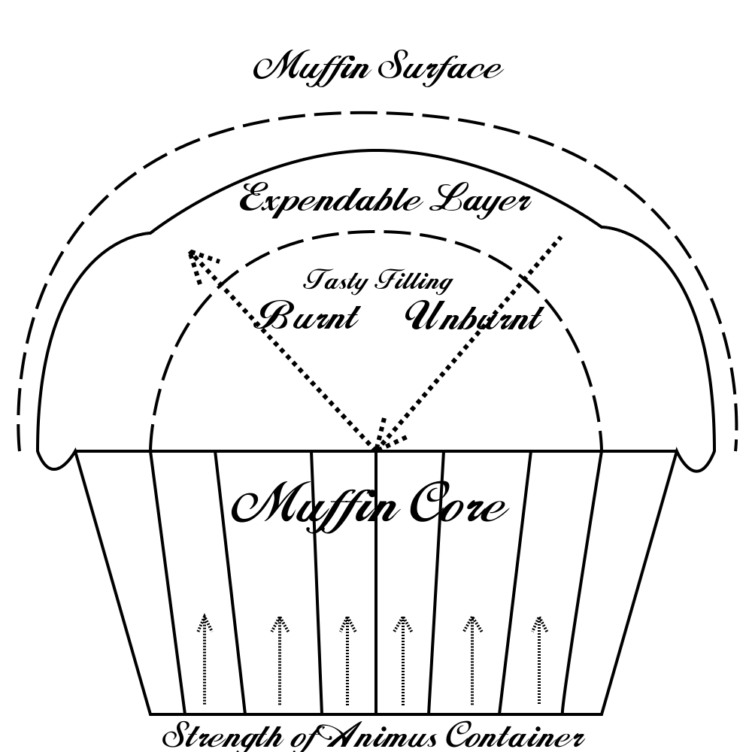
Second among the powers is a necrotic fire shield. This induces a modified fire shield around the target that lets damage heal the target through necromantic transmutation. It is evidenced by a glaring sheen to the skin with a distinct feeling of intense cold. This effect is usually used in cases of grievous harm where fire is available or threatening. Shield mechanics will repair internal damage at the expense of external burns though through necrotic conversion. The reconstruction will be more extensive than the damage since the damage is consumed as the power source but it nonetheless does result in spiritual trauma as well as some burns from unconsumed damage. This will not be used as first resort but if a token bearer is being burnt alive leaving with their organs otherwise unharmed but sustaining very severe burns this may be preferable to other options. Alternately if a target has broken ribs and a punctured lung their campfire-burnt hands will prove easier to deal with over the long term than a lack of proper breathing. As it mentioned the necromantic effect causes some spiritual damage on its own during transfer that will take at least a week to heal. (18) Muffins are a good example so Kreen will use those in the diagram on the top right of this paragraph. Though the damage that migrates outwards is not limited to burning alone the muffin will keep its tasty center unburnt like a human target would. This is of course as long as the expendable portion still remains and the muffin cup providing base strength has not received too much damage from the process to keep the muffin upright. It is very inadvisable to sustain multiple fields before first naturally healing the spiritual damage as much as baking muffins in the same burnt cup more than once. It is possible for one's heart to simply stop if the spirit becomes too weak. Drain from balancing will not cause the spirit to sustain this level of injury intentionally as it has safeguards to stop before that point but this means that there is a maximum physical tolerance before the healing ceases that depends on the target. A human of common physical tolerance is unlikely to sustain more than a minute of total immolation before the fire begins damaging internal organs or in the case of the muffin burning important tasty filling. Though it cannot transmute any more damage into repair at that point Kreen can enable the effect to simply drain the incoming fire or inhibit flesh from splitting to produce a shielding effect. That will not prevent eventual death if the weakened individual is not removed from danger and treated immediately.
Thirdly as the more long-term solution Kreen has empowered the preserver with another necromantic transmutation. The preserver can turn a plant that has large seed pods or bears fruit into a Bloodberry plant. Not all plants can be transmuted in this fashion but trees or ground berries are the most common targets. (19) This transmutation was researched by defiler druids in a more offensive nature but Kreen has repurposed it to be less dangerous and much more passive. The target tree becomes completely albino as the Bloodberry plant is parasitic. The root system ranges at least double or triple the distance of the original plant and instead of taking sustenance from the earth removes it from nearby plants of at least half its size. Also, the tree will inherit the hibernation cycle from its base or become perennial and gain a hibernation cycle if required but in the end will be immune to disease or death from age. Originally the drain from parasitism was much more proactive but in being altered to be safe the Bloodberry will not cause plants or moving targets to die from depletion. As from its origins Kreen would note that a deceased sentient present or interred before transformation will cause the primary stem to become red. This will double the plant's strength and thus production due to its source but Kreen obviously does not condone this method unless a willing donor exists. The transformation takes a week to a month to complete before the plant starts producing fruit. Afterward the plant will produce berries to a predictable maximum related to size then resume growing. Each berry produced will induce a small bit of overall healing in those that eat them but the effect does not last more than a few hours after being detached from the tree thus they must be used on-demand. Incidentally Kreen is told they taste like a cross between sugary fruit and raw cinnamon though are fairly moist. In no case can the plants be produced from seeds or cuttings as Kreen has removed this capacity for safety. The trees will die if they have no suitable life in range to trickle life from but if their berries are full to the maximum the plants will expand at half their species normal speed and their already expansive roots will range further spreading their relatively minor drain among more plants. They have been shown to be invasive to graveyards so they should not be planted near them. Animals generally find the berries inherently unpalatable as they only taste good to intelligent creatures. The fruit was originally bait. Insects tend to be wholly absorbed if they penetrate any sizable plant's bark.
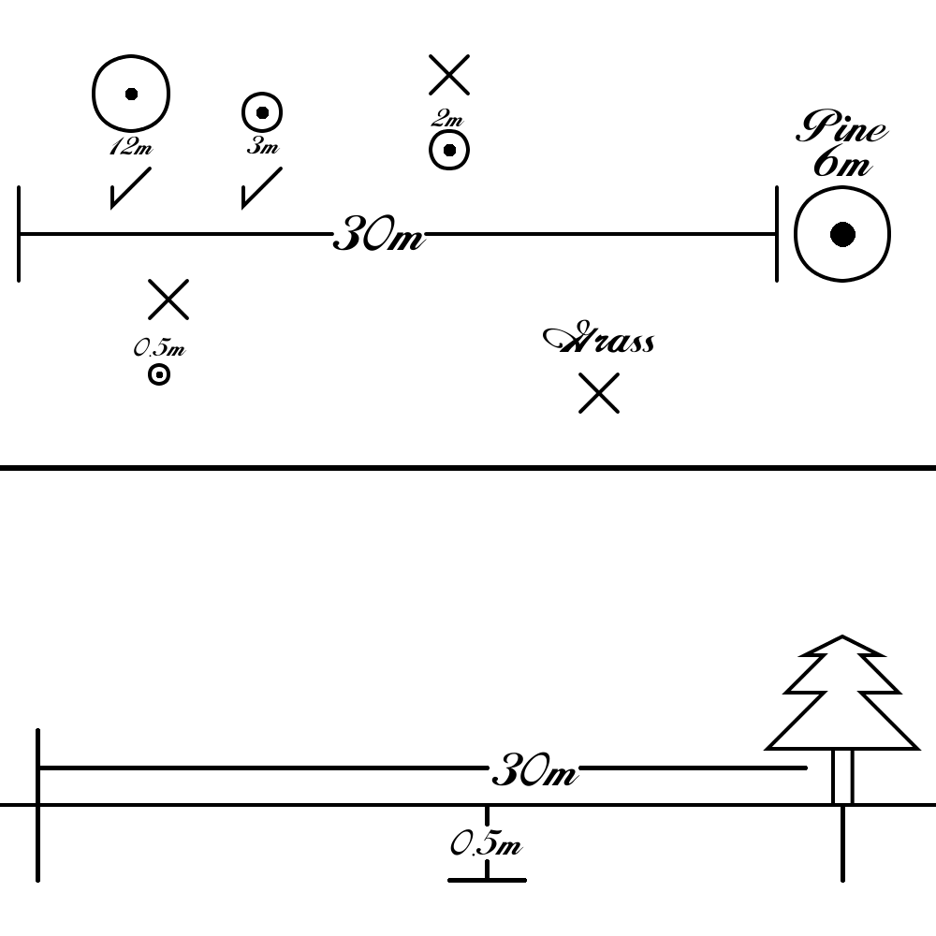
Example: 6 meter high pine trees could be expected to maintain approximately 5000 mature hand sized berries out of cones each with enough strength to heal small cuts. Roots might spread approximately 30 meters in radius in the top half meter of soil. (21) A Bloodberry tree of this size would most likely produce 3-5 berries a day depending on how many healthy trees at least half its size are present in its root range. As the smaller 2m and .5m tall trees grow in size they will eventually add into the strength of the parasitic bloodberry and the two trees currently used will be used half as much to gain a comparatively smaller amount of berries. Grass, though plentiful, will never have a significant enough root system or plant size to attract the bloodberry and they will be ignored.

Plant Tender
Plant tenders see that the mythal radius has the maximally sustainable density of plant life to further the total amount of mana available to the gate and thus inhibiting mana burn to the environment from extended portal activity. Climate or environment changes that affect plants may result in their need to be moved to more suitable locations and thus the plant tenders see to that all plants are in areas at least minimally healthy for them to exist in. They also see to the removal of invasive plant species that may be brought to the mythal and damage density potential and biological variety. It remains fairly difficult for the metasentient to make such determinations about proper health of plants and things it cannot directly perceive even though token bearers have these capabilities. Thus limited token bearers with forest management skills of any significant measure will be shadowed by the plant tenders for immediate resolution of any issues they perceive whether or not explicitly noted. Kreen will equip the plant tenders with basic knowledge of the nature of plants and forests as to not overly tax the minds of those they are relying on for judgment.
As the plant tenders may need to expand or spread species from time to time or to repair damage their first power will be that of simply storing seeds. This enables them to retain up to a hundred seeds for porting a short distance into the earth. Token bearers with forest or planting skills will often be permitted to hold the seer and directly employ their abilities as the token bearer desires. (23) The seeds stored must be removed either into a pile of the remaining or fully planted into the dirt before more seeds can be retained. This is due to the low-power nature of this ability as bidirectional extradimensional spaces of dynamic volume consume much more mana. The range of the ability is approximately a meter including the depth planted underground.
Vilyan's purity is a small part of Vilyan's dryad spirit that Kreen has duplicated into a power for the seers. As it is very familiar with Vilyan's spirit Kreen can make the power very mana efficient. It's primary duty is to allow the tenders to sort individual specie between two locations in the mythal. This allows the tenders to evict invasive foreign species to a specific area where they can be removed. Alternately this allows the tenders to segregate trees infected with a virulent disease as to prevent its spread. The strength of this power is heavily dependent on the amount of token bearers with a skill in plant management and a token bearer with such skills can apply it with more elegance than the metasentient. Two of these areas 3 meter square can be designated that must not overlap though with more token bearers in the mythal these areas would increase in size. The metasentient can only use them contiguously but a token bearer can distribute the surface area in any way that does not overlap. Once these areas are chosen either the metasentient or the token bearer can temporarily integrate a a plant into the core using portal equipment and it will trade locations with a visualized spot or plant in the destination area of space. Though transferring these equal spaces requires moving some dirt at times any roots that may intercede with objects will be warped around them and any other plant matter at the destination. (24)
The seers or the token bearer using the power must be familiar with or able to view both areas, fully and completely identify the plant, and finish moving one plant before another can be moved. The effect will remain as long as the seer or token bearer concentrates on the activity but once concentration is broken the power ends the staged power matrix. One use is depleted until it can be staged again by the seer. Kreen would advise only well skilled token bearers use this power as should the token bearer fail to retain enough detail and proper knowledge about the plant the end result at the destination may be terminally warped beyond recognition. This will not effect intelligent plants or spirit hosts for safety reasons such as treants, dryads, or dryad trees but most everything else can be moved.
The last power of the plant tenders is to bring a set of immature or congested plants to fruition by combining their mass. This enables the Seer to untangle areas of dense growth or intergrown plants by merging the individual plants of the same species directly into a combined plant. If the plant is already at maturity this can sometimes result in a larger than normal specimen though not all plants will tolerate such abnormality and the pattern adapter may split them into equal volume specimens below their maximum size split evenly into what would have been the combined area size. (25) As with Vilyan's purity power Kreen advises it to be employed only by those with excellent knowledge of the plants involved or there is a chance that the combined specimen will be unhealthily deformed. The area affected is dependent on the plant as it will be approximately twice the normal root radius of the target plant to receive the merge or at an arbitrary location with a range of three times the average mature size of the species involved.

Cycler
Cyclers are a design that Kreen made so that any organic waste, dead plant material, or forest detritus can be immediately reused by the ecosystem but not recycled in a way that may produce unwanted effects by consistent necrotic magic use. These seers will only operate in the daylight and not hibernating as Kreen feels it is better not to tamper with plants while they may be dormant even if negative effects are unlikely. If a token bearer feels the need to use the seers' abilities at night they may do so but the metasentient will otherwise remain inert until sunrise. Measures were taken to ensure they do not cause undue harm to the environment by their activities as their main function is for the most part passive. Their duties will be first to recycle organic detritus on the forest floor or abandoned human materials that will successfully rot. Second they serve as a continuous knowledge of the state of the plants they've seen for the last week and as such know when those plants have been altered. Kreen has also equipped these cyclers with the ability to discern the basic habits that produce unwanted vermin or fungus so they can identify such unwanted when given directives by token bearers.
The first of their abilities is that of accelerating the decomposition of organic matter. Only unliving unattended organic matter will be targeted for safety reasons. This restriction results that this ability will ignore sentient creatures (dead, undead, or living) and will shield any other living creatures or plants from the amplified natural decomposition. The total field area is a field effect approximately .44m^3. Anything within this area (distributed as a cube of even dimensions) will experience drastically accelerated decomposition that should amount to 28 hours per second exposed to the field. Each token bearer within the mythal will amplify the regulator managing the effect giving another 6 hours of effective decomposition and the volume is doubled if directly employed by a token-bearer. This ability is inherently adverse to altering inorganic substances and such things as iron will not see any rust effect even if immersed due to induced shielding. Note that as a secondary effect of their decompose ability the areas where dealt with may have as many large common mushrooms as they do small plants. The field that protects living plants during decomposition can be extended to specific types of fungus if token bearers later desire to identify them to the cycler but as large fungi assists in the accelerated decomposition process it will leave them be by default.
The second among their powers is to reemerge trees and ensure they are maximally healthy and strong. This requires a fairly large amount of energy for its energy neutral effect due to the regulation and structure interpretation required for Kreen to safely alter potentially varied and unknown plant structures. This ability can only target one specific plant at a time and even if intertwined unless actually conjoined into one whole. Trees are the primary subject of this effect but minor plants can be used though it would be waste likened to a sledge used to smash a grape. Dead or dying branches are absorbed into the tree's substance and used to heal damage to the tree and induce stronger wood structures first most. Secondly the power will expend the remaining material to grow the tree as is natural once it is healthy and strong. As in the diagram the four uneven limbs would remerge first, the trunk damage would repair, then if any mass remains the tree would expand naturally that amount. If a token-bearer is wielding the seer they will be able to direct the power to grow specific limbs from the tree or enhance ones already present. Though if new limbs are grown the token bearer only chooses location not structure. Alternately a token bearer can simply choose to participate in the enhancement of the natural growth and the plant will expand naturally for as large as the interpretive structures deem it safe to do so.
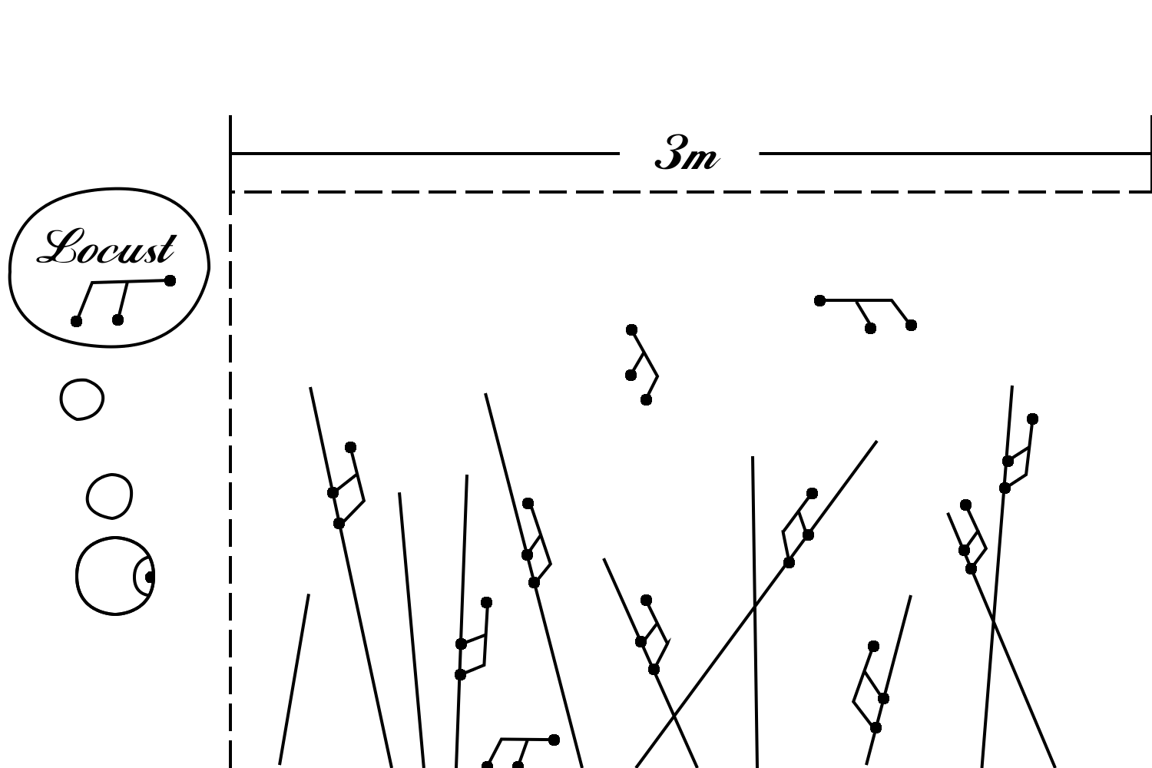
The last power is that of an ardent banish to purge unwanted foreign living things from the area such as lethal fungus infections or locusts. This involves their destruction so this power must first be authorized for a specific instance unless such things as a cloud of locusts presents a clear and present harm. The seer must first prepare targeting templates for specific threats and this can be done in a general fashion on its own but token bearers are needed for anything immediate. Things larger than an average locust will need direct interaction of a token bearer to create and store the template. Once the desired templates are stored the power will dehydrate anything matching the specific template and concrete the rest of the matter into mineral enriched sand during disintegration. This may cause damage to plants in the case such things as fungal infections but should not prose a lasting harm. The area affected is a cube oriented area equal to 28.3m^3 that doubles in volume if employed directly by a token bearer (56.6m^3). Should a token bearer use the effect it also may be distributed in any shape with a specific dimension no smaller than .6m.

Gatekeeper
Gatekeeper Seers have the duty of inducting or evicting token bearers and discovering the location of lost token bearers. This ensures that if a token bearer goes missing they can be found and seen to as well as providing conventional access by token bearers for inducting others into their number. Kreen reserves a right for itself to induct or evict any tokens from the core as the conjugate gate is tightly bound to itself and the token bearers it leaves behind may not be the nice people it left given spans of time Kreen can be gone from places. Kreen also can designate a last authority among the token bearers that the metasentient will respond to requests for inducting a being without majority assent though that person must also be a token bearer. (27) To facilitate the process of inducting and approving new token bearers Kreen has enabled the gatekeeper with abilities to discern the nature of body language and indications of mental subterfuge. It compares normal thought among the token bearers to that which is found in those demonstrated to have lied enabling a token bearer to instinctively assess the truth of applicants. This is not foolproof but should provide a valuable tool in such matters. A limitation of this tool is that it can only discern the nature of applicants that share any race already a significant portion of token bearers. If the applicant is of a foreign race not shared by token bearers little more than superficial information will be imparted.
The first power of Gatekeeper Seers is that of altering token storage. The gatekeeper can accept a new token or remove one from the core. Items that can be accepted as tokens, as Kreen mentioned earlier, can only be things that are personally important to the potential applicant. The given example being that a flag signifying a soldier's affiliation with the state would be of little use, but a bullet removed from a fallen comrade could be a token. If the token is not personally relevant enough to the inner mind of the applicant attempting to form an entry point into the mind will fail. A copy of the token's substance is imaged onto the core as a piece of virtual mythallar that can be used to repair the actual copy to the state in which it was accepted. This also means that in order for the token to be altered it must be viewable by the gatekeeper in that tattoos must be fully visible, the item must be presented, or a piece of jewelry worn. This image also allows the Ordermonger seer to recreate or repair tokens imaged onto the metasentient should they be damaged or lost as they will technically be known parts of the mythal. Nonetheless without the item the token bearer will be unable to assert any privileges. A limitation to this would be that a Ordermonger cannot recreate a tattoo on a nonexistent arm and the tattoo cannot be changed to a new place as that would alter the known design in the core. Living objects such as the arm cannot be refurbished by the nature of the Ordermonger seer in any case.
Location of token bearers is another function of the gatekeeper though this is extended to other token bearers if they are close enough. As long as the token bearers stand within the mythal the metasentient can determine where they are. (28) As token bearers accept the metasentient into the recesses of their mind, in so doing become them, hiding their location from themselves is unlikely at best even if it could not acquire their location from the connection to their mind. The token bearer can choose to hide themselves from other token bearers and the precepts of the metasentient will prohibit it from divulging a location that would possibly lead to injury for any reason. Allowing judgment of valid injury would require the use of the pursuer's faculties and thus always show proper. Any intended injury will deny whether it is from another token bearer themselves or from their assessments of another likely intending harm. Obviously, a token bearer that does not want to be located can discard their token and will detach from the metasentient.
To allow for the use of others in lieu of unoccupied token bearers the metasentient can offer a sentient being the opportunity to give an oath of service. This will confer access to the seers without committing untrusted individuals to the whole of the metasentient. The offer itself is a temporarily imposed memory that can be accepted by the receiver as true. Should acceptance occur the recipient will already know from the memory what is to be done and under what conditions to complete it. This temporary glyph memory will last 96 hours at best before being ejected by the host mind and the metasentient perhaps seeks another from loss of contact. Loss of contact could also occur if the oath-bearer leaves the plane but the meta-sentient would be marginally aware of this if it sends someone elsewhere. In this way any difficulty that presents itself in delaying completion will in general automatically receive reinforcement. Both the metasentient and the recipient will be aware once the recipient feels they complete the oath but Kreen expects the metasentient to ensure the duty was done. Those whom betray the oath or do not complete it to satisfaction will be remembered with the minds of token bearers so that those perhaps unworthy of trust are not immediately reused as extra help. Token bearers holding this seer can give an oath to a recipient of their choosing though if the recipient is deemed to have violated the metasentient's precepts the token bearer will likely be found and their token evicted.

Darkeyed & Brighteyed
Kreen made the Darkeyed seer design for the purpose of cheap sensory nodes for dark spaces. As such their powers are fairly simple and uninvolved. Most of their strength comes in physical design so they are sensitive to wear but the Ordermonger will maintain them. Kreen will make a great number of these as well as Brighteyed seers for purposes of surveillance by token bearers. The Darkeyed enable human sight while token bearers are not present and the Brighteyed enable human sight while token bearers are present.
The first among their powers deals with perceiving their spaces in their ideal environment. Darkeyed are made sensitive to the shadow plane as rectified by the material for others to observe through them. This means that shadows will be fully lit as much as brightly lit spaces will be pitch black. The darkeyed will still be able to see normally if required. The converse is the Brighteyed that possess a power to make items within a cone to luminescent. This should allow the seer to light the way for humans to proceed. (30) It is not a particularly bright light but enough to make human eyesight not stumble over glowing surfaces in the dark or step in holes.
The second among their powers deals with brightness in their vicinity. The Darkeyed may not wish to be easily seen by their environment and so they may suppress light sources or its reflections in their vicinity. (31) It is a standing fairly unstable effect centered on the Darkeyed that should last up to 3 hours and spans from half a meter to nearly three. This ability can be made more stable by a holding token bearer used as a local regulator easily doubling its effectiveness. Brighteyed conversely are so that their environment can be more easily seen. The power is a sphere centered on themselves approximately twice a man's height though it varies with the amount of token bearers powering the mythal as this particular component is easily made scalar. Its purpose causes all light within the slightly perturbed field edge to be uniform that erases all shadows to produce a uniform noontime light within the sphere but not without it.
The last of their powers allows their respective numbers to shift to where they are needed provided the central locus type is present near the destination. The Darkeyed may shift to any observed or well-known shadowed area within the mythal. The Brighteyed may shift out of any similarly known or observed light source of sufficient direct strength to make a human avert their eyes and sufficient size in perceived aperture of light emission to fit their substance through. (32) Token bearers may employ this ability directly if holding the seer but this increases the necessary aperture radius from which to emerge. Darkeyed are well suited for this purpose as token bearers may take issue with a Brighteyed that totes them out a bonfire with which to fit them through. This would likely alight hindquarters in the process if not burn outright. Darkeyed may use any area of very minimal or absence of light to open an aperture and these places are found in size much more easily.

Ordermonger
Damage is a concern in the long term stability of the gate so Kreen makes a design of seer that will maintain its substance. Should any serious pattern damage to the core occur due to severe changes in the environment Kreen will need to attend to it directly for safety. (33) As such the Ordermonger will only attend to wear in the metasentient's core and not replace parts. As these duties are trivial to be adapted to repair possessions that the token bearers find precious it has so modified the design for willful control. Parts of the mythal's design are inherent however and the metasentient will only be able to repair damage or wear to items that the token bearers themselves have the knowledge to create. As Kreen mentioned in the gatekeeper seer design an exception for the tokens exists as the entire state of the substance is imaged directly onto the core. Other than this exception for tokens to repair foreign material schematics a knowing token bearer is required. Still, Ordermongers will attend to any item they see as worn or damaged in ways that token bearers deem fit for maintenance. Direct intervention by a knowing token bearer speeds up damage assessment then repair but left to their own devices they attend often to stone, metal, or glass. Repairs to living material require matrices that Kreen cannot contemplate safely so any use on such things will fail. Nonliving solid plant fiber can be repaired as well but other animal materials such as leather previously made of flesh cannot see proper maintenance.
First among their powers is a low power glyph work by which to rectify light wear or damage. Its purpose is for common and sustained use and as such its effectiveness at joining parts and smoothing damage is very weak. Broken untainted pieces held tightly to the break can be repaired if an excessive amount of material was not lost at the joint. Scratches or light fractures can be easily sealed or smoothed but an attempt by a token bearer to alter the intended object during repair will fail as the glyph work has no such interpretive provision. As such token bearers assisting in repair must first know what the original form was. Token bearers within the mythal will assist in the part of the metasentient that considers order from stimuli so that the proper state of things can be ascertained. As such the Ordermongers will likely gain enough free thought to repair approximately 6.5cm^2 base surface repair size plus the same amount more per token bearer active in the mythal with negligible increase in thickness from 5mm. Pieces of the mythal being repaired have a base surface repair size of .09m^2 since the structure is explicitly known. (34) The simple glyphs are not equipped to resolve more than that amount of free thought per unit mind. In the case In case it is not clear Kreen will remind that raw material is required to form into repairs but also as it mentioned token bearers can repair anything token bearers' themselves know the composition of. This sustainable power has a short range as methods to deal with attenuation of order are mana consumptive.
Second among their powers is a much stronger version of the first. It shares the same properties and limitations except as follows. The repair area is the same but it may be distributed in any contiguous shape of equal volume. Raw materials may be used to fill in missing ones rather than smooth out the damage from the existing area into more sturdy forms. Purification of the material is too expensive as is transmuting impurities so Kreen advises raw material as used by token bearers be as pure a solid mass as possible as it will concrete them directly in portions provided. As it has methods to deal with the mentioned attenuation of order in the first power solid nonliving materials inside a living or otherwise solid object can be repaired at a maximum distance of 2 meters from the surface. Outside of targets in solid objects this power attenuates much less over range but should be usable over a distance of 10 meters without loss of effective repairs if the environs are amenable. Note that the penetration distance is not in excess of the total usable range. (35) This would be used in the instance of a tree occupying some portion of the external space of a brick house and such things or to repair reinforcement bars inside walls. Deformation or damage unoccupied by solid living mass can be repaired or nonliving mass purged. Deformation with living material occupying the space to be joined cannot proceed without severe damage to that portion of living material as this power's methods do not have the necessary translation glyph work to deform living tissue safely to the external range of repair.
Last of their powers is that of refurbishing. Should mythal parts be terminally damaged Kreen may not be present to form new ones. As such this power can be used to reform any part from sufficient raw material and any leftover mass of the part. The leftover mass of the part is not required but it will aid in the duration it takes to reconstruct the object. The duration to repair is dependent on the amount of materials involved and object complexity but can be estimated at approximately twenty minutes per kilogram. (36) For the purposes of the gatekeeper any tokens imaged onto the metasentient are considered parts and can be refurbished from memory as can most other parts. The metasentient core is too delicate to have its parts refurbished and will have to rely on self-integration of raw mass or direct repair by Kreen itself. Token bearers can use this power to create anything they themselves know how to create all components of or have schematics they can understand available containing all details of order involved in its creation. If all parts are not well known or available by the token bearer then accuracy would be unlikely. Magic items can be repaired in this method but the token-bearer must understand the magic involved as it is a component. Lastly to clarify the effect of material quantity if insufficient materials are present the part will be as inferior as its intake material and likely hollow in small portions if missing but still functional as long as at least 75% of total mass is present. (37) Such parts would likely persist up to two weeks before failure or outright glyph degradation. Corrupt or impure materials are discarded in favor of pure materials even in broken pieces but if not enough pure raw material is present these corrupted parts are likely to fail at anywhere up to four months. The impurities are still regarded as damage however and the major repair power can replace the corrupted matter should pure material become available.

Diggers
Kreen may need additional storage or underground residences for token bearers. It is easiest if Kreen builds these underground. This purpose prompts Kreen's design for an excavation schematic. (38) The digging method Kreen uses is too weak to impact strong materials such as granite or marble but it has made allowances for slow advancement through such areas. Tunnels produced in this habit if diggers are left to their own devices default to a maximal continuous hardened wall thickness before advancing in a given direction. Token bearers can significantly improve construction speed in the way of arches and pillars where the tunnels would otherwise be sparse smooth stone boxes with hardened walls. (39) Kreen has encoded a basic knowledge of load , structure, and geology but a construct intellect can only be employed to simple ends by the metasentient alone. To pass the time if not allowed to dig anything their instructions are to further destruct their rubble piles and sort them into visually distinct materials. What these materials are and how valuable they may be is beyond encoding in such a small space. It is possible however to detect the deceased and the diggers will attempt to excavate around an area that has a bodies in it unless told to do otherwise. If the token-bearers as a whole have reverence for the site but choose not to obstruct the digger's activities a crypt may be constructed underground if a mason or stone worker is present to obtain skills from. Other such interactions of the whole with the diggers for things found underground are entirely possible.
As another example: creatively obsessed individuals such as extremely prolific token bearing stone carvers may make the diggers absent minded while not assigned tasks and instead decorate any stone surface they can decorate without weakening a structure.
First among their powers is a digging tool. Using flat force planes either in spiral or chisel fashion the diggers drill free then vacate matter into a temporary extradimensional holding area until their portion of the area is full. Approximate dig rates are as follows: 17m^3 of dirt or clay per hour, 34m^3 of sand per hour, or 1.7m^3 of medium strength stone or shale per hour. (39) As Kreen will mostly require digging basements or perhaps a well for water the digger's storage space is made ideal for loose medium such as dirt since Kreen has instituted automatic storage and compaction passes of loose shards within the temporary extradimensional storage space divided among diggers. The total storage space available to the diggers is dependent on the number of token bearers providing the intellect to track these discrete extradimensional spaces used for storage in the conjugate gate's continuously active reference plane. It has ensured that at least an entire six seconds of digging can be stored before venting but each additional two token bearers will increase storage by .03m^3 per digger as two primary glyph matrices used to share the load of holding management are not compatible with each other in the same mind. The aperture and draw used for absorbing material is under control of the seer so that flat surfaces can be produced via drilling. Pieces absorbed however cannot be very large and the aperture is not sufficiently robust to absorb more than a function of the amount of storage in a single object even if it has an amplified stable access to the reference plane. Maximum diameter is equal to the root cube of the volume the digger has access to as the aperture must fit within one side of the evenly distributed storage space. (40) This will make any ore veins or bedrock difficult to deal with as they are often too hard to mine by force plane but the diggers can divert around them until the veins can be removed by other means. Sparse objects such as gemstone geodes may be too hard to mine through but small geodes beneath the specified maximum aperture size can be subsumed in whole. Materials such as these will be dumped in a different location than normal rock as they are instructed to do so.
Second among their powers to allow for slow movement through bedrock or reinforcement of tunnel walls. Specifically this power alters the hardness of .28m^3 of volume in any flat spatial configuration no smaller than 10cm along any dimension. The gate will open a localized portal storm of minute individual proportions in the area with a targeting tolerance of 0.5cm. (41) The direction of substance draw will either concrete matter to the other side of the portal surface or isolate links into discrete portions. Generally a single micro portal storm can disrupt matter one step along the following scale as small matter's bonds get comparatively stronger relative to static portal size. Stone becomes Shale, Shale becomes clay, Clay becomes dirt (coarse sand), and dirt(coarse sand) becomes fine sand. (42) Along this scale it is noted that disrupting lower than clay involves stresses that affect organic substance and water. These materials will be ripped apart in something similar to immediate decomposition and so produce dirt. This dirt if stressed another time will concrete the organic matter directly into other minerals forming a fine sand. Organic material cannot be created from sand without additional directed transmutation so hardening fine sand produces coarse sand. The Seer must be within very close proximity for point of observation as well as targeting. Even so this power cannot disrupt strongly ordered substances such as crystal deposits. As metal ores in the local portal locus area will bend the field, deposits are generally too strong to be significantly altered by this ability. Nevertheless Kreen strongly advises that the area be absolutely ensured to be clear of life before activating the ability as it will have disastrous effects on living things.
The last power is for the sake of removing vast quantities of solid material from the area. A much larger extradimensional space is maintained for this power akin to the first ability and only one digger can employ this at any one time due to reference plane constraints. This however has sufficient power to have a flexible aperture and can intake approximately four metric tons in weight. Volume isn't as much a concern as the reference plane will adjust to accommodate but while in locomotion the remote aperture is only strong to a certain exit pressure exerted by the pocket in space relative to the substance it contains. (43) Due to limited refraction effects from the aperture seal that avoids light or air buildup in the reference plane the effect looks as a area of distorted light with a slight graying from light loss. The seer does not control this sphere in as much as it sets intake and outtake locations. The spell construct will go to the specified location then suspend the lower portion of the aperture seal to take mass in through a levitation vortex. Anything not affixed to the earth will be subsumed through the aperture into the temporary reference plane holding space over the duration of approximately an hour depending on how heavy the individual unit of debris is. The seal is sensitive to damage however so care must be taken that individuals do not damage the aperture seal in transit or the entire extradimensional space on the reference plane will propel its contents omnidirectionally at speed. It does not intend the sphere to sound fragile but as a whole intentional attacks from high powered weaponry are likely to break the seal and uncork the wine bottle. (44) Normal venting is regulated to simply fall out in a downward direction and should not pose any appreciable risk of projectiles as long as nothing is underneath. The metasentient will avoid venting mass into areas with living things anywhere directly nearby and can hold venting for an indefinite period though this means the holding area is in use. (45)

Waterflit
As a reliable and clean water supply is essential to the proper functioning of an enhanced forest and thus mana supply this design of seer has the express purpose of ensuring that such a water supply exists. (46) Its primary duty is to filter bodies of water of contaminants that are disposed of securely. The metasentient will order diggers to prepare sealed stone cisterns in which the Waterflits can dispose of contaminants deemed harmful for later disposal by token bearers. If the materials to be sequestered are not too dangerous the cisterns will be constructed underground. In the absence of water bodies to effectively filter the diggers may option to prepare large cylindrical wells deep into the earth for purposes of accumulating water. If bodies of water are available they are equipped to either create or transmute water into the environment to meet the forest's needs as their powers note. Unlike other Seers that cannot effectively maneuver underwater Kreen has equipped Waterflits to pass through water at below a human average walking pace. If threatened Waterflits will hide as deep in the nearest water source as they can find up to 150 feet which is their maximum safe depth. Kreen has also instilled enough knowledge into the Waterflits that they can discern between qualities of water sources but this knowledge is neither expansive nor detailed.
The first power of Waterflits is to filter substances and impurities from water. This is a non-selective filter for efficiency and it relocates all non-water non-living substances from the water to a predetermined reference point within the mythal. The seer does not have direct control over the destination point for the materials but the metasentient does and maintains the apertures on the reference plane that will direct the impurities to materialize in cisterns. Kreen has added a selection requirement that the fluid to be filtered be an unattended source composed mostly of water as to reduce its possibility of becoming a nuisance while unattended. The filtration rate of this power is approximately .63 l/sec though the Waterflit may need to move itself and thus the 50cm square targeting plane to sweep out impurities or spin it in place at a body of water. The targeting plane is centered at a point 40cm away from the Seer's eye and can be rotated freely around that axis. (47)
The next power of the Waterflits is that of transmuting simple fluids into water. Kreen notes that this power will not be used without informed consent of a token bearer due to the potentially poisonous properties of its remainder. This power enables any simple compound to be reconstituted into water using parts of that compound. The remaining unusable portion will be vented into the same local space. It is advised that this ability be used in a well ventilated or protected area as some of the base gases exiting the powered aperture may prove hot enough to burn, flammable, or prove exceedingly toxic but they will definitely be noxious to most. The aperture itself can be up to 10cm in diameter and materialized within standard seer range. (48) The water will be vented elsewhere in the mythal to the nearest large body of water or a location of the metasentient's choosing. This should allow for the processing of most filtered impurities into a usable quantity while disposing of compounds into component parts that are less harmful by themselves. The maximum amount of fluid volume to be transmuted in this fashion at any one time is 7.5 liters and must be fully drained up to the amount before transmutation occurs.
Lastly Kreen has employed a gate reference for use in acquiring enough desalinized water to supplant the entire area though this immensely reduces the amount of times it can be safely used. This ability summons clouds by an aerating gate aperture into the elemental plane of water. Put simply this power summons a thundercloud into the top range of the mythal. The gate cannot be active while this power is in use as it requires the attention of at least 5 Waterflits to process the fully encoded glyphwork for the remote aperture and at least 15 token bearers due to mutually exclusive glyph groups in use. (49) Also Kreen limited this power to wait until the reference plane used by the conjugate gate is again processing at least 90% of normal background unrealized plane threading and the sourcers are at a similar full level. The reference plane will ensure all objects passing from the elemental gate are evicted back to their plane. It does not expect any serious issue as the apertures are too small for objects to pass through and water elementals will be destroyed by aeration if choosing to try passing by force. Should objects still advance through safeties exist to abort and vent that planar fabric in reference space back into the elemental plane. (50) The vapor will either begin immediate precipitation or spread a half day before doing so at a later date dependent on environmental factors. The elemental plane of water does not itself have a pressure until after a portal and impulsion exists but the resultant aperture-based flow pressure should vent several hundred thousand liters into the plane before the reference plane loses too much integrity dedicated to the purpose to safely maintain the elemental portal.

Whisperers
As Animals may become a problem for token bearers or be protectors of last resort Kreen makes the whisperer seer design so that they can be contained or employed. (51) Kreen does not wish to enslave creatures so it has not designed powers that produce this effect. Seers are of a limited intelligence however so Kreen has given them habits to follow any token bearer that demonstrates skills in animal handling or exhibits druidic effects. Kreen will also instill general knowledge of the larger animals within the mythal area from friend Bitflipper's books as in lieu of any rangers the seers will daily loan competence to select animals to attempt to perform tasks or simply to observe. It knows humans must eat but Kreen warns that a token bearer directly observed as killing an animal within the mythal will likely be met with the memories of that attack as read from a this dying animal and installed forcibly into the hunter. Kreen does not inhibit this possibility as it may introduce an unwanted loophole into the interpretation method of the precept to undo lasting harm as best able.
First among their powers is an interpretive glyph work for use in making animal memories suitable for implantation into token bearers or other sentients. This should aid in any searches for missing persons or intruders. The memories will be simple and devoid of instinct but they should prove useful for sensory and emotive knowledge. The strength of memories and thought must be fairly strong as Kreen cannot amplify the memories of very small beings to usefulness of interpretation so the animal must be at least the size of a rat. Insectoid memories are too rigid if present at all to produce proper memories so they are often read as blank even if appropriate size. The metasentient can transfer the memories gained to any token bearer within the mythal but the amount of memory imparted is directly related to the adaptiveness of their mind. Individuals of high intellect will likely be able to retain more than an hour from present of memories read from the donor animal as the total spark of memory will be linked more fully before fading.
The second power is that of the interpretation of damage in ground or plant so that a ranger may track individuals within the mythal through the breadcrumbs they leave behind. The seer must first choose a recipient that already possesses tracking skills then it will impart knowledge of all damage or alteration to the environment to the chosen target as a blue glow based on the level of alteration to the plants or earth. Blood will show as a red glow instead. The range of this processing of observation by the metasentient is limited to approximately 6.15m but is increased by the level of ability in the token bearer. Attenuation control of the divination will fully fade the signal at 10m.
The last and strongest power possessed by the whisperers is that of loaning competence to animals. This will provide the animal with a sentience based on its own experiences which is supplanted from the sentients taken as token bearers. It is likely for the animal to take on a male or female persona as per its gender. The seer must link and focus on the animal during the link so observation from its point of view will be inaccessible while this power is used. It is possible for the animal to knowingly resist the bond so Kreen has put safeties in place for the seer to back out if resistance is detected. This power is fairly strong however so the seer may not notice too weak resistance until after the bond completes though it may back out if the animal cannot be convinced of the seer's benign power. As a large portion of the higher reasoning is derived from token bearers the animal will speak languages known by their majority. Assuming they possess an adaptable enough voice to speak they can do so but the seer will communicate its wishes to the animal directly through the link. The seer can terminate its relationship with the animal if it does not prove amenable to the metasentient's needs or precepts. In any case once the seer terminates contact the animal may lose the ability to fully interpret memories gained in the meantime.

Firebug
As forest fires or widespread fires in general will prove extremely detrimental to the proper functioning of the mythal Kreen makes this design so that the fires can be stopped from spreading or small fires quenched. (52) The habits of this design is predominantly that of looking for smoke and/or fire. In order of dealing with fire they will first attempt to extinguish the flame with their primary power then if this fails the metasentient will inform token bearers. In the case of a large fire they can clearly not quench the firebugs will make a scorched zone around or in front of the blaze to halt its advance. Lastly if these effects do not work they can take proactive measures to drench unattended areas with a mass port of a body of water above the blaze's center.
First among their powers as it mentioned is that of inhibiting flames. This inhibits consumption of fuel in the area slowing the fire's advance and possibly starving it completely. Large fires will override this power so this cannot deal with large blazes with strong centers. This can reduce a flame's advancement by three quarters for every 30 seconds of inhibition but only over a space of 0.5m^3 as Kreen has made this glyph group low enough mana use as to be sustainable. (53)
Second among the powers is that of scorched earth to create fire breaks. This power will consume all non intelligent easily combustible material within the zone of effect. Its dimensions spread as a projection from a central plane parallel to the seer oriented to gravity at a maximum range of 10m. The plane itself is 3 meters deep by 4.61m high with an additional 3m underground. The consumptive ray projection is distributed among all firebugs with active projection apertures to a maximum length of 3m without token bearers to assist. The available length is doubled if the projection plane depth is halved. The size of the standard projection plane is 3m deep, 4.5m above ground, and 1.5m below ground. (54) Kreen advises that persons be kept from the area where the metasentient is directed by to put a fire break by token bearers as the pressure wave will temporarily deafen, singe, or at least knock down anyone within 8m of a location with any significant fuel. As safety measure to prevent immolation of those sentients accidentally caught within the area the combustive effect will deform in a cylinder around a sentient's immediate personal space plus 25cm in radius. This is very likely to still result in burns from radiated heat and pressure but they won't be baked alive by their possessions.
Kreen provides the last power for the specific use of a last ditch effort triggered by token bearers. All firebugs must be present to use the reference plane to store a contiguous body of water within a 20m sphere and evacuate it onto the center of an advancing fire. As doing such a mass transport is extremely mana expensive Kreen cannot add filtration methods to keep solid objects out of the relocated space and so any objects floating in the body of water or a natural lake will be teleported as well. The process will not disturb the solid objects or their immediate vicinity in any significant fashion but the fall from a hundred meters or more is likely to be problematic for any previously floating fish or boats. (55)

Main Prevalent Powers of the Mythal
The mythal has a few prevalent powers present anywhere within the mythal but Kreen has kept them to a minimum. As it mentioned in the description of these mythals every prevalent power or spell has a side effect but Kreen can enumerate the nature of these side effects as it designed the metasentient that passively induces these balances. It will present the power then the associated side effect in order.

Etheric Grounding
Magic use of high power is very destabilizing to a standing conjugate gate especially when initiated at close range but Kreen also wishes to protect those at the portal from strong rogue mages seeking mythal parts as much as it safely can. In such need has put in place an inhibition of ritual magic initiated on site. Things such as these hellstrikes that friend Bitflipper has told Kreen about could be countered but the structures involved in dealing with such massive endpoint expenditures of high war magic with a metasentient mythal would amplify its corresponding side effect to a level that is invasive to humans at even its base level of mere detection. No ritual, high magic, spells above the 7th circle, or glyph working can be initiated by unauthorized parties within the mythal as this power is effectively a disjoining shredder for such detected forming structures. It should not damage any magic items or constructs but should they activate the grounding will take effect. Token bearers are not subject to this power due to structural limitations and Kreen is encoded in the mythal workings as exempt so it can build parts as its position in the mythal is easily verified with internal connections.
As much as Kreen would like to make the area safe against hellstrikes as it mentioned it will not do so as the risks are too great. These risks Kreen speaks of is that the inhibition of magic structures results in the imposition of 'expected' order on new life within a certain power level that attracts attention of the side effect formed from the glyph group. Since it has only restricted the initiation of such powers on site, thus requiring a minute amount of energy for inhibiting a casting in comparison to snuffing an endpoint of one, the new life in question should remain that of small animals with size and natural intellect complexity somewhere between that of rodents and medium domestic dogs. Any attempt to disjoin an endpoint of such hellstrike powers would likely advance its complexity range directly into range of sentient birth complexity and remain there even if the energy were directed to inducing growth in every plant contained in the mythal which would be the obvious and only target for that kind of moment of absorption. (56) Some powers use Sylvan patterns directly from Vilyan causing that level to be within reason for reassembly of her species' structure as well as other templates. Dryads, and either sylvan fey or possibly fey native to Bitflipper's plane depending on where the template patterns are sourced from would be likely subjects. These imposed patterns of vast spare capacity would also have enough strength to change the birth race's inherent properties regardless of the parent species and would breed true if remaining visually similar to the parents in some respects. Though Kreen thinks males receiving a enchantment to template Vilyan's patterns would prove inviable glyph structure and fail safely to whatever species the male child was. Incidentally, dryads do not have male children. It has not considered that level of power of potential toward an induced template source in depth as it will be a non-issue with current design. The increased effect would be unwanted imposition (that it can't predictably regulate) on others especially for those that expected to be either sterile or infertile and Kreen will not force such happenings to other sentients.
Those small animals whom are subject to the power have a chance within the mythal for an altered birth with minor magical inducement that will not breed true or affect normal lifespan for the species' soul for the same reasons of limited power. Whether or not the animal is actually fertile the chance of pregnancy will remain as long as the requisite activity and equipment is present as the side effect should evidence as a standing enchantment that wreathes the female parent as connected to the affected birth. The chance for a birth to draw targeting in the initial waveform divination range of 500m centered on the core should be approximately 40%. The side effect's targeting and thus chance will then deteriorate rapidly for such a distance attenuation in losing half of its strength every 5% of the distance remaining to the end of the mythal range where it is zero. (57) The effects are likely to be benign to the animal since Kreen creates powers to be well-structured as well as highly tolerant. The side effect would be unlikely to induce stillborn or deformities other above the normal occurrence of such things. It may be possible for a regenerative squirrel or chameleon fur rabbit to be born or other such minor powers in small animals. Complexities for effects like a standing fireball or even magic missile glyph forms are an effective impossibility as only natural properties are subject to the induced pattern template.
Note: The standing enchantment on the female parent sustains the affected birth and should it be dispelled the birth will expire immediately with its animus only partly transmuted. The standing enchantment cannot be reliably reestablished in such a short time. Even if accidental or known ahead of time the enchantment is of enough unique but chaotic nature that it will resist Kreen's attempts to decipher it for recasting in any time period reasonable by human standards. The effect will persist however even if the parent leaves the mythal as the side effect is transitory and only establishes the enchantment.

Seerhome
The second power prevalent within the mythal is that of the control structure for seers. This ensures that the seers have a power source as well as a secured connection to the metasentient that is not easily subverted by outsiders. Other than this duty the power does little else than facilitate communication with token bearers. Token bearers can observe through the monocular vision of any Seer in the mythal should they learn to concentrate properly on doing so. This does not impart control but it should be excellent for surveillance and the metasentient will still respond to token bearers to observe locations or patrols indirectly through their desires. (58) It will activate any recognized seer within the mythal that reenters range should they accidentally or be stolen then begin ordering it about to the needs of the metasentient. Should a control path already exist with another sentient or the particular seer is unknown the metasentient will not intercede in control and only sustain the object's power needs. This prevents unknown constructs from being inserted into the core but leaves a method of expansion for any future necessary mythallar constructs.
This power is likely to only have an annoyance for mages caught unaware. Their memorized glyph groups have a chance to be rebalanced to other mages if they acquire too many seer glyphs in a 30 day period. Load balancing should avoid any one mage acquiring such levels of glyph groups but it still may occur. When such a randomization occurs a low glyph balance mage and the overbalanced mage may trade metasentient memories as well as some of their memorized spells. (59) Kreen does not expect other detrimental effects from normal memory rebalancing even if balancing improperly selected patterns. In any case if the mage is informed of the effect ahead of time or been subject to it once the mage will be able to hold on to their own memorized spells with a small amount of concentration kept to awareness of them.

Night Watch
Kreen felt it would be well to help identifying those entering the mythal as to prevent sneaking through the forest. This power is a simple faerie fire keyed to different colors for different targets. This is keyed to spirit type and should be difficult to avoid but false positives are possible. The field is barely a candle's brightness but should be visible in the dark as the effect does not work from sunup to sundown. (60) It is also ineffective when the target is standing on well paved roads, underground, or inside structures as those surfaces interrupt projection of the field. This counts mostly for buildings made of dead tree flesh however. Living buildings, sitting on trees, or in trees will still gain the field. Token bearers can discard this spell at will so they can use stealth.
This power will likely make a bit of gloom to the nearby forest in that moonlight does not reach past a tree's canopy unless bright from at least half moon. When it is bright enough for moonlight there will be a visible gray fog at least a human deep on all areas the faerie fire targets. The same is true for the darkness itself and areas paved or such places it mentioned as not applicable to the faerie fire spell will receive the full brightness of the moon as long as canopy isn't in the way.

Restful Resurgence
Humans sleep too much for Kreen's liking. Kreen can't directly heal exhaustion but it prefers that humans not have to sleep so much when it works with them. As Kreen has the opportunity to offer a solution it has crafted a spell that can be completed by those bearing life magic. Deific magic or druids can complete this spell from the broadcast magic though it is limited to a range of a quarter of the total radius of the mythal emanation. The effect is that the target immediately enters deep sleep for four hours once they go to sleep. This also amplifies natural recovery and a single four hour period equals that of a solid day of bed rest without the risk of atrophy from being idle too long. As this power is merely a spell supplanted by the mythal it has no side effect other than remembering all of any dreams during the rest period.

Sourcers
Sourcers collate raw glyph nodes produced by raw mana within the mythal range and cache it for use by powers that would cause damage by direct draw from the ley. As such Kreen's powers are built around these raw units of mutable magic power. They cannot persist in such complex forms outside of the ideal environment inside the compressed containers. The Sourcers themselves refine the glyph shards produced by the environment and should there be a breach the first response to ensure safety will be to burn off enough energy to transfer the store all glyph shards in the damaged sourcer. It will take a great deal of effort to actually breach all four sourcers at the same time. Nevertheless Kreen has made provisions for a backup method of burning off the stored energy in that the mana glyphs will be concreted into solid form. This solid form should be a stable blue iridescent crystalline structure that will decompose in approximately 96 hours. (61) The ordermongers should be able to refurbish any sort of damage to the sourcers within that period. Should both these methods fail a true breach may result in a temporary surge of wild magic at altitude but should not damage anything on the ground should it occur.
The gathering itself is dependent on the quality of land within the mythal range and how much life is existing within the area. Kreen has provided a power of thirds to estimate refinement in various area types. Estimation of friend Bitflipper's cities may be low as they seem more dense than Kreen is used to but it should hold true in a general sense though perhaps more dense than per kilometer. Usage of Seer powers are one unit of each magnitude of glyph and they take directly from the sourcer. The other powers are ongoing and draw units to use over time. Kreen has detailed all the power draws and sourcer capacities in the summary. Unused portions of powers are returned to the sourcers as to not waste any shards that can be refined again into whole units.

Conjugate Gate
Once the conjugate gate is established Kreen will open horizons on both sides for transit. Anything entering the horizon must enter fully before emerging into the conjugate plane. All four conjugate planes will be observable from outside with regulated leakage enabling transparent overlay but the inside will be a perfectly flat white plane bounded by a spheroid ripple distortion. The base plane used as a floor has the grip of hardwood but is otherwise perfectly flat. The floor extends to the bounds of the sphere and continues beneath it but the ripple distortion as viewed from inside will be opaque white on the egress. On the destination side a scaled view of the city will be present through the ripples until targets exit at the horizon on the exit side and return to normal space. The inverse is true for things entering the plane from Kreen's side. They will overlay transparently as very small until emerging into Bitflipper's plane at appropriate size. (62)
There are quadruple redundancies in Kreen's design for all parts that maintain the conjugate gate as should it destabilize all substances inside will cease to exist in normal space. It is very unlikely for Kreen to retrieve things that vent directly into nondimensional space assuming they remain in whole parts so it strongly ensures that all systems can function with three out of four portions damaged though all run to share the load and account for systemic surges and to ensure the backups run.

Concerns
Friend Bitflipper wishes Kreen to consider some things so it will address these in turn. It does not know much about friend Bitflipper's science but it will answer in the best way it understands.

Environmental considerations
Kreen thinks friend Bitflipper means its effect on the environment and in this sense it affects a great deal of things. The mana consolidation is benign and does not impinge on life as the sourcers draw it at a sustainable rate and refine the mana gained from the environment so it can be more efficiently used. The sourcers will not connect a part directly to the weave where the gate is located so there is no risk of mana burn though the abilities may turn off until there is sufficient refined glyphs for them to operate. The metasentient is unlikely to allow its energies to get this low. Construction will not destroy any more trees than the physical footprint of the gate and sourcers will occupy and a road suitable for acquiring resources without destroying terrain. The road may wind to minimize culling but it will need to be somewhat straight and some trees may need to be removed. Gate activities will more than replace the trees removed in this manner but it has no interest in removing trees for mere ascetics sake. The Seer designs mentioned above can manage the animals within the area so that they can be left alone and it will not intentionally destroy homes of animals. The land itself may be altered and shaped to maximize the amount of trees that can grow and how large but Kreen expects the Metasentient will not choose to do harm by removing the home from a creature that requires rocks and such to exist. Kreen would like to remove some water across the gate but Kreen will see that it does not take more than it can replenish.

Pollution
Pollution is contrary to both Kreen's needs and the conjugate gate's goals. The seers will be working to abate the effect of pollutants on the environment as to increase the forest's diversity and size. Pollution during the construction process will be taken care of manually and will consist forge emission, organic waste, and metal impurities. Most of which will arise as Kreen must build tools to make the tools it needs to build parts. Kreen will limit its use of the forge to batches and see if humans have a better way than for Kreen to make a coal forge so it can make the shock forge. Organic waste can be composted and metal impurities or other arcane scrap Kreen can deal with through any way human forgers dispose of them now. It may retain scrap it can reprocess so it can use it to make parts to self-repair. Once the gate is constructed any pollutants found on land will be dealt with by waterflits then sealed in stone cisterns so they can be disposed of more readily. (63) In this sense pollution amount in the completed conjugate gate mythal area will be a negative value. Water pollutants will be filtered as a healthy forest requires clean water so the water table may improve over time especially if a large bore can be dug so waterflits can access the aquifer directly. (64) If there are things such as lead or quicksilver buried in the earth they will be disposed of also in protected stone cisterns then sold or disposed of safely. Kreen can use either so it is sure humans may have a use for both or other impurities it may encounter. Cycle Seers will dispose of rotting material or things that can decompose but some human waste may need to be dealt with by diggers if it will not decompose. Kreen refers to glass though there may be other such materials left behind by others in forested areas that will be collected by Diggers as unknown ore being neither decomposable organic material, stone, metal, nor dirt.

Emissions Allowances
Kreen expects forge work to be fairly clean as it can work on the inside as not to lose heat overmuch. Some parts it will have to be bought from a metalworker with advanced forging tools as Kreen cannot make them with tools it can build from scratch. The gate itself will give off some Ozone while active but not in any significant amounts. The gate does emit quite a bit of light while active but other than this it does not expect any significant material output from the gate. Most loose metals or dust from the atmosphere will be concreted to stone construction for use in resurfacing repair by ordermongers but wear may leave dust at a relatively neutral value.

Visual and Aural Emissions
The gate is fairly noisy when engaging but will only have a mild hum and the rush of coolant air once the conjugate gate is established. When starting the gate the sourcers will glow a fair amount but will should not be significant compared to daylight and barely show through the forest. (The next stage involves a shift in local space from forced spatial grafting. This will evince itself as a momentary jolt felt for some distance but will not be of a magnitude that would cause damage if felt at all. It isn't sure how friend Bitflipper measures earth moving but a single detectable vibration of little consequence is all that will occur at this stage. The next stage involves the creation of the local conjugate endpoint and this will be a bright light that fades in strength from a white sunset to the full blue moon over the space of 5 minutes. This will involve barely audible directionless static heard a few kilometers away for little more than a minute that will evolve into regular tones that fade off. This tonal noise would be largely a mental effect for sentients due to the quantity of mana expended at this stage and will sound different for each listener. This noise is a passive effect of no real consequence. The last stage before locking involves making synchronization passes of all sensory nodes and mages in the mythal area may feel slightly oppressed by the load on the local forest though it will be lessened over time. This feeling will lessen over time depending on how fast the forest can be safely strengthened. Final stability and superposition locking onto Kreen's main conjugate gate will involve four more jolts the same strength as the first but in rapid succession. The four clangs of plane-sped metal from the locking rings may carry a few miles then a few moments after the rings will sound like deep thunder all at once in the sound's maximum propagation range due to hyperplanar echo. After this point the gate may make the forest radiate slightly blue but other than a mild hum in the forest it will remain unremarkable through dispersal which is another final vibrational jolt. All this should pass in 7 to 10 minutes. Tests may take longer but not significantly so and Kreen can make an announcement to avoid significant disruption to other human activities or mages. When not engaged for use the conjugate gate is completely silent and visually inert as Kreen will contain the sourcers in their own stone buildings and the remaining minute vibrations will be muffled with ponds.

Transit Warnings
There are some things that those passing through the conjugate gate should know ahead of time. The air inside the gate may be thin within a minute or two of creation so breathing may be difficult but it should not be hazardous. There will be a numb sensation from passing through the horizon and whole units must enter before exiting into the conjugate gate. This is to ensure proper spatial merging. Each merge into the conjugate gate plane will cause a 1.5 minute delay from the closing of the individual horizon but will be instantaneous from the traveler's perspective. Initial entry into the horizon will be a flat white space of the temporary discrete merge space but will be fully breathable before any travelers can enter though they will be unable to see anything in the featureless unshaded space. During this 1.5 minute delay for merging the travelers will momentarily be invisible from either side though their outline can be seen if looking at another horizon straight-on.
As for actions within the conjugate gate one at the controller's position can adapt power input to accommodate energy loss from spells cast near the active gate or from individual active magic items. Kreen very much would prefer to be advised of the such activities ahead of time. At no time should spells above the 5th circle be cast near the active conjugate gate nor from inside. Casts from inside the gate subplane may cause severe instabilities to the conjugate gate's operation before Kreen or the metasentient can act to adjust for them to operate safely. Should an individual cast such a spell inside a single conjugate gate plane successfully causing the subplane to exceed maximal power supply for the interval the subplane may be unable to persist. Fail safes are in place to ensure everything in that gate subplane is safely merged to the other gate subplanes leaving the individual caster in planar stasis until enough energy to resolve the unrealized power imbalance is marshaled. Once the mana is provided it can merge the individual into one of the other subplanes and recreate the missing conjugate gate subplane. Explosives may cause damage to objects inside the subplane for a moment but such rapid accelerations of energy just as magic will trigger the fail-safe and sever the proximity of the expansion into temporary stasis. If the materials inside the stasis space are unwanted or hostile Kreen can intentionally vent the space into any of the coterminous planes such as the astral or ethereal.
Any leftover mass in stasis or in progress of merging when Kreen runs out of stored mana from the Sourcers to maintain the gate for another interval will cease to exist in real space and be segregated into any number of nearby coterminous planes. Likely into multiple very small portions. Kreen will not allow horizons to open when this is a risk. Objects not in stasis relative to the reference subplane in the remote conjugate gate but currently in the conjugate gate subplane will lose access to the side of Bitflipper's plane as this remote-side reference subplane will have insufficient energy to create horizons into the conjoined space. Those inside will still be able to leave to inner Kreen in their own time as the mana cost for a single conjugate gate plane group is low enough to the machine as to be within margin of error in measurement equipment. Once all are safely across Kreen terminates the gate plane group from internal side.

Creation Resources
Money may be a problem as Kreen will need to purchase various materials to make the gate. It hopes to auction the three deadhand watches for good amounts to fund the project. Unfortunately Kreen is not familiar enough with Bitflipper's currency or market to estimate a cost of the materials it will need. A large quantity of metal will be needed but Kreen can manufacture the tool chain it will use from raw materials though this may take a few stages. The main tool it will need to make will involve a lot of ceramics and copper for conduction. Other machining tools can be easily manufactured once the shock forge is in place. As Kreen only has one external body it will need help to run the shock forge as it is of size and Kreen doesn't have time to manufacture a shock forge that can be completely controlled from inside.
Persons would be preferable for assistance as Kreen thinks creating undead for labor may be looked on badly by the populous even if it could get donations. In that case Kreen will use its skills to offer limb replacement in lieu of cash payment for the project's duration. If friend Bitflipper is amenable Kreen will look through the list of injured soldiers from the last war to make an offer for regimented labor for the aforementioned payment. The replacement leg will not be the original as Kreen cannot create life but it can make an undead limb and bond it safely to a living being. The limb will have to come from a blood relative for it to take with certainty but the socket Kreen makes on the stump to interface will persist even if the limb is rejected. A wrap will be added to ensure the strength of the limb and protect it from wear and damage. The undead limb will be a parasite but in a technical sense so was the original and the side-effects are minimal. The owner of the limb would be slightly more hungry (for normal food, not brains) than normal and the limb has no specific senses other than a general temperature and pressure on limb and such.

Mythal Property Summary
- Range: ~3km radius from core (~29.2 km^2)
- Sourcers
  - Safe refined glyph aggregation per day per 2 km^2 (general estimation)
    - Managed forest: 9 major, 27 medium, 81 minor
    - Wild Forest: 3 major, 9 medium, 27 minor
    - City: 1 Major, 3 medium, 27 minor
    - Scrub/light forest: 1 major, 3 medium, 9 minor
    - Wasteland: 0 major, 1 medium, 3 minor
  - Storage maximum per sourcer: 16 major, 48 medium, 144 minor
  - Total storage: 64 major, 192 medium, 576 minor
  - Refined glyph draw
    - Etheric Grounding: 3 major per use and 1 medium per day for its divination sensor
    - Seerhome: 6 Major per day for the contact nexus and 1 minor per seer per day
    - Night watch: 1 minor per day per target
    - Restful Resurgence: 1 Minor per casting
    - Conjugate Gate:
      - 20 major for approximately 15 minutes to maintain local reference plane (used in whole units of time)
      - 5 medium on horizon opening for plane creation
      - 1 medium per unit mass that passes into a horizon
      - 1 minor per human entering the gate or inside the gate plane to engage sensors that properly rectify the use of magic items and realities unprocessed within extradimensional spaces preventing implosion of those spaces.
- Time to create compiled glyph plans for core and important parts: 8 Days
- Preferable resources present during mythal casting on core:
  - 30 token bearers or mages equal to them to assist in spell casting (Kreen would pay for their time)
  - A mage of sufficient strength to cast the spell (Kreen would have to test personally or otherwise train to strength)
Smelters or forgers may be able to use the greensand though it does not know what the dwarves did with it. Once the conjugate gate is completed Kreen can sell that or steel ingots once repairs are complete. In any case Kreen will see that any debts are paid during completion if not after it.

